

User Guide

User Guide to Word Bookmarks

Setting up, understanding and using Word Bookmarks
User Guide to Word Bookmarks
Version 2020 R24 (2020)

Copyright
Copyright © 2007-2015 by Efficient Workflow Solutions, LLC | All rights reserved

Trademarks
MoversSuite is a trademark of Efficient Workflow Solutions, LLC.
Microsoft and Microsoft Windows are registered trademarks of Microsoft Corporation.
All other product names used are trademarks of their respective owners.

Notice
The material in this document is for information only and is subject to change without notice.
While reasonable efforts have been made in the preparation of this document to assure its accuracy, Efficient Workflow Solutions, LLC assumes no liability resulting from errors or omissions in this document, or from the use of the information contained herein.
Efficient Workflow Solutions, LLC reserves the right to make changes in the product design without reservation and without notification to any person or entity.

Edition
2015
Copyright © 2007-2015 by Efficient Workflow Solutions, LLC | All rights reserved

Printing Information
Printed in the United States

Technical Support
If at any time you experience problems with MoversSuite, we encourage you to contact us as follows:

Toll free: | 1.866.750.7255
Phone: | 1.970.256.1616
Fax: | 1.970.256.1650
Websites: | www.ewsgroup.com
Support: | support.ewsgroup.com

Table of Contents
Word Bookmarks 4
Custom Word Bookmark Documents 5
Word Bookmarks Setup and Administration 10
Bookmark Fields 11
Claims Bookmark Fields 12
International Bookmark Fields 14
Order Information Bookmark Fields 17
Quote Bookmark Fields 22
Special Services Bookmark Fields 23

Word Bookmarks

Word Bookmarks provide users with the ability to transfer data to labeled text fields in Microsoft Word documents, allowing for the creation of custom documents based on MoversSuite order information such confirmation and thank you letters.

Bookmark documents are reports in MoversSuite that display as options for menus in the following locations.

Location | Description
Claims | The Reports/Letters menu provides users with the ability to generate bookmark documents based on a selected claim record.  Refer to the System Report ID Setting of “CLAM” for setup information.
International Orders | The Forms menu in Shipping Information provides users with a list of bookmark documents specific to an international order.  Refer to the System Report ID Setting of “INTL” for setup information.
Military/Government | The Military Forms button provides a menu of bookmark documents to generate for the open military order.  Refer to the System Report ID Setting of “MILT” for setup information.
Quote | The Reports/Letters button provides a menu of quote specific documents that a user can generate for the order.  Refer to the System Report ID Setting of “QUOT” for setup information.

When the application generates the bookmark document, it opens a Microsoft Word window and replaces the bookmark fields with data from the open record. For example, MoversSuite provides a sample bookmark document titled Confirmation.doc. This document contains a bookmark of “LastName.” When the application generates the document, it will replace this with the data from the Last Name/Company Name field in Name, Address, Phone.

See Custom Word Bookmark Documents for information on modifying existing or creating new bookmark documents.

Refer to Bookmark Fields for a complete listing of all available bookmark fields.

Custom Word Bookmark Documents

Users can copy and paste Bookmark Fields into any Microsoft Word document. Users must save the document to the appropriate version of Microsoft Word residing on the application server. For example, if Microsoft Word 2003 is installed on the application server, the document must be saved as Microsoft Word 1997-2003 file through the Word 97-2003 Document option in the Save As menu.

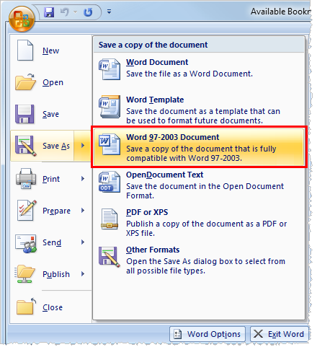
Figure 1: Save As options

Once in Microsoft Word, use the Bookmark screen to add MoversSuite bookmark fields from the list of Available Word Bookmarks. This screen is available through the Bookmark option in the Links menu of the Insert ribbon.

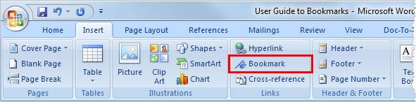
Figure 2: Bookmark option from the Insert ribbon

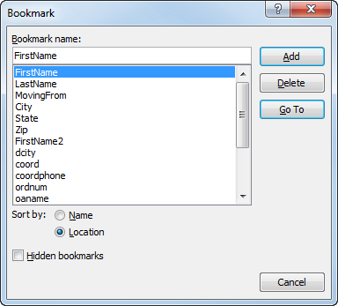
Figure 3: Bookmark screen

The following table describes the function available within the Bookmark screen.

Function | Description
Add
This function will place the entered or selected bookmark into the document at the place of the cursor prior to inserting a bookmark.
Delete
Remove the selected bookmark from the document using this function. Text of the bookmark will remain, i.e. removing the “FirstName” bookmark will not remove the “FirstName” from displaying.
Go To
This function takes the user to the location of the selected bookmark within the document.
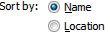 | Sort by  Users can choose to sort the listed bookmark fields by their Name or by their order of occurrence within the document (Location).
Hidden bookmarks
Check this option to display all bookmark fields including those used internally by the application.
Close
This function closes the screen.

Users must enter the Bookmark name value exactly as it displays within the Bookmark Fields listing. For example, enter “LastName” to insert the shipper of an order. The following example illustrates the use of the following bookmark fields:

FirstName
LastName
MovingFrom
City
ST
Zip
FirstName2
dcity
coord

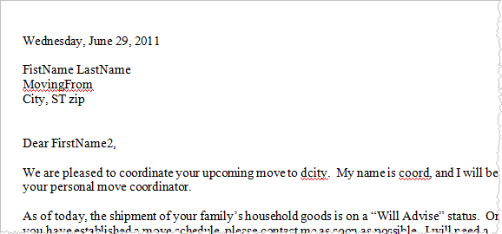
Figure 4: Sample bookmark document

Please note the use of “FirstName2.” The “FirstName” bookmark displays the First Name/MI field of the shipper taken from Name, Address, Phone, however, the application allows only a single use of any bookmark field therefore MoversSuite provides a second bookmark field (“FirstName2”) to also extract the first name of the shipper. The more commonly referenced values have more than one bookmark for them, such as “LastName,” “LastName2” and “City” and “dcity.”

Users must enter the bookmark fields through the Bookmark screen. Users can do two things to help ensure that they correctly entered a bookmark. One is to copy and paste the exact bookmark reference from Bookmark Fields into the document; and (2) turn on the Show Bookmark option.

The Bookmark screen example below displays the correct bookmark references in the correct letter casing.

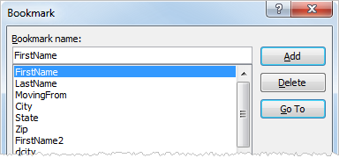
Figure 5: Bookmark screen

When the Show Bookmark option on, Microsoft Word will display bookmark fields in brackets.

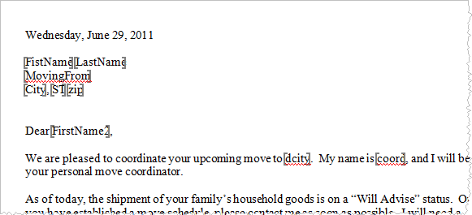
Figure 6: Sample bookmark document with Show Bookmark option on

Set this option within the Show document content section of the Advanced Word Options.

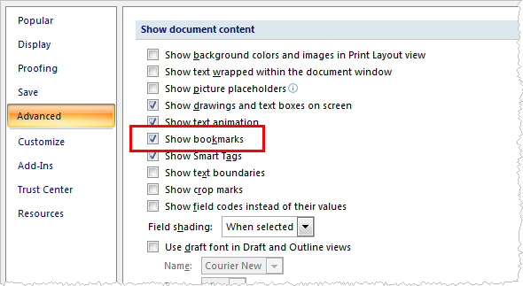
Figure 7: Advanced Word Options

In order for MoversSuite to recognize the document, it must placed on the application server and be defined in Report Setup. See Word Bookmarks Setup and Administration for details.

Word Bookmarks Setup and Administration

The following table describes the setup related to Bookmarks.

Setup | Description
Report Setup | Use this setup to define menu options referencing bookmark documents. Set the following options for all bookmark documents.  Report Name  Reference the physical name of the custom Microsoft Word document including file extension, e.g. “Confirmation Letter.docx.”  Report Path  Enter the location of the Report Name file on the server. MoversSuite installs place standard bookmark files in the mssShare\mssLetters folder. MoversSuite suggests placing a copy of any customized bookmark documents within a subfolder of the mssLetters folder, such as “Custom,” and reference the fully qualified path such as the following:  “\\server\moverssuite\mssReports\mssLetters\Custom\”  Render Type  Set the type to “Letter” for each bookmark document.  System ID  By default, the bookmark documents are available through the Letters group (defined in Report Group Setup ) and also associated to the Report Setup record.  Set the System ID to any of these supported System Report ID Setting values: “CLAM,” “INTL,” “MILT,” “LABL”, or “QUOT.”
Personnel Setup | Assign users to Report Profile records containing bookmark documents.
Shipper Phone Type Setup | The phone types defined within this setup are referenced within the Shipper Contact Information section throughout MoversSuite, commonly through Name, Address, Phone and Order Information (Revenue Entry), are used to retrieve a particular phone number as a bookmark.  There are several standard types already defined as bookmarks. They include “Origin Home,” “Origin Work,” and “Destination Work.” However, all defined phone types can be referenced as a bookmarks by placing a “pt” in front of the type and then removing all spaces. For example, if “Cell Phone” is a defined type, then define a bookmark of “ptCellPhone” to retrieve its value from the order.

Bookmark Fields

Click on the Microsoft Word icon () to download this document as a Microsoft Word 1997-2003 file containing the actual bookmark field values.

The following table lists the groupings of Bookmark fields available from MoversSuite.

Group | Description
Claims Bookmark Fields | This section contains the bookmarks specific to Claims.
International Bookmark Fields | This section contains the bookmarks specific to International Orders.
Order Information Bookmark Fields | Bookmark fields for general order data list in this section.
Quote Bookmark Fields | Quote specific bookmarks list in this section.
Special Services Bookmark Fields | Bookmark fields specific to Store Information display in this section.

Claims Bookmark Fields

The following table lists all bookmark fields available from the Claim Detail screen and Claim Items tab.

Field/Data | Bookmark Field
Claim Detail fields
Claim Number | ClaimNumber
Claim Adjuster | ClaimAdjuster1  ClaimAdjuster2  ClaimAdjuster3
Claim Type | ClaimType
Claim Status | ClaimStatus
Valuation
Valuation Description | ValuationDescription
Declared Amount | DeclaredAmount
Shipper Deductible | ShipperDeductible
Dates
Alert Received | AlertReceived
Date Created | ClaimOpened
Claim Form Sent | claimsent
Actual Claim Received | claimreceivedactual
Date Closed | ClaimClosed
Actual Closed to Customer | claimclosedactual
Claimant Name & Address
Claimant Name | Claimant
Claimant Street Address | ClaimantAddress
Claimant City | ClaimantCity
Claimant State | ClaimantState
Claimant Country | ClaimantCountry
Claimant Zip | ClaimantZip
Summary (Claims) field
Settlement Amount (Posted) | SettlementAmount
Claim Items bookmark fields
Claim Items |  | ClaimItems  The following data will display for each record associated to a claim when this bookmark field is in use  Description  Claim Damage Type  Claim Amount  Settlement Amount

International Bookmark Fields

The following table lists all bookmark fields available from the Shipping Information tab and Booking Number screen.

Field/Data | Bookmark Field
Service Provider
See Origin Agent within Order Information Bookmark Fields for related bookmarks.
Origin Linehaul Agent Name | OriginLinehaulAgentName
Origin Linehaul Agent Street Address | OriginLinehaulAgentStreetAddress
Origin Linehaul Agent City | OriginLinehaulAgentCity
Origin Linehaul Agent State | OriginLinehaulAgentState
Origin Linehaul Agent Country Name | OriginLinehaulAgentCountry
Origin Linehaul Agent Postal Code | OriginLinehaulAgentPostalCode
Carrier Name | IntlCarrierName
Carrier Street Address | IntlCarrierStreetAddress
Carrier City | IntlCarrierCity
Carrier State | IntlCarrierState
Carrier Country Name | IntlCarrierCountry
Carrier Postal Code | IntlCarrierPostalCode
Consolidator Name | ConsolidatorName
Consolidator Street Address | ConsolidatorStreetAddress
Consolidator City | ConsolidatorCity
Consolidator State | ConsolidatorState
Consolidator Country Name | ConsolidatorCountry
Consolidator Postal Code | ConsolidatorPostalCode
Customs Agent Name | CustomsAgentName
Customs Agent Street Address | CustomsAgentStreetAddress
Customs Agent City | CustomsAgentCity
Customs Agent State | CustomsAgentState
Customs Agent Country Name | CustomsAgentCountry
Customs Agent Postal Code | CustomsAgentPostalCode
Destination Line Haul Agent Name | DestinationLinehaulAgentName
Destination Line Haul Agent Street Address | DestinationLinehaulAgentStreetAddress
Destination Line Haul Agent City | DestinationLinehaulAgentCity
Destination Line Haul Agent State | DestinationLinehaulAgentState
Destination Line Haul Agent Country Name | DestinationLinehaulAgentCountry
Destination Line Haul Agent Postal Code | DestinationLinehaulAgentPostalCode
Other Information
Origin Port | DeparturePort
Final Destination Port | DestinationPort
Airway Consolidator Bill (HAWB) | ConsolidatorAirwayBill
The following data is from the Booking Number screen
Booking Number | BookingNumber
Pickup Contact
Pickup From Name | PickupFromName
Pickup Number | PickupNumber
Street Address | PickupFromStreetAddress
City | PickupFromCity
State | PickupFromState
Country Name | PickupFromCountry
Postal Code | PickupFromPostalCode
Phone Number | PickupFromPhone
Return Contact
Return To Name | ReturnToName
Street Address | ReturnToStreetAddress
City | ReturnToCity
State | ReturnToState
Country Name | ReturnToCountry
Postal Code | ReturnToPostalCode
Phone Number | ReturnToPhone
Airway/Seaway Bill Number | AirwayBill
The following data is from the Bill of Lading Consignee screen
Consignee Contact | ConsignToName
Consignee Street Address | ConsignToStreetAddress
Consignee City | ConsignToCity
Consignee State | ConsignToState
Consignee Country Name | ConsignToCountry
Consignee Postal Code | ConsignToPostalCode
Consignee Phone Number | ConsignToPhone
Consignee Fax Number | ConsignToFax
Ready To Go Date (Estimated) | ReadyToGoDate
Origin Port Departure Date (Estimated) | DateDepartOriginPort
Destination Port Arrival Date (Estimated) | DateArriveDestinationPort
Vessel/Flights Information
Vessel/Flights Information | VesselandFlightInfo  The following data will display for each record associated to an Order when this bookmark field is in use:  Vessel/Flight  Estimated Departure Date  Actual Departure Date  Estimated Arrival Date  Actual Arrival Date  Destination Port

Order Information Bookmark Fields

Field/Data | Bookmark Field(s)
Order Number | ordnum  ordern
Current System Date | date
Branch Setup bookmark fields
Branch Name | blname
Branch Street | baddr
Branch City, State Zip | bcsz
Branch Phone | bphone
Branch Phone Extension | bphonex
Branch Fax | bfax
Work Ticket Title | Bname
Name, Address, Phone bookmark fields
Shipper Contact Information
Last Name/Company Name AND First Name/MI | fname  FirstName2  Shipper
Last Name/Company Name | LastName
First Name/MI | FirstName
Phone Type of “Origin Home” | phoneh
Phone Type of “Origin Work” | phonew
Extension for Phone Type of “Origin Work” | Phonewext
Phone Type of “Destination Work” | Dphonew
Phone Type Bookmarks
All available phone types can be referenced as bookmarks by placing a “pt” followed by the phone type without any spaces. For example, if your company has a custom phone type of “Cell Phone,” you can reference it as “ptCellPhone” in bookmark documents. This works with all available phone types (defined within Shipper Phone Type Setup).
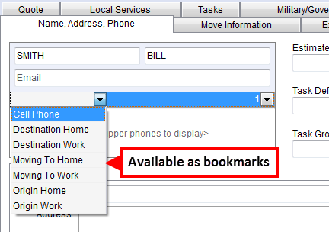
Figure 8: Phone type drop down on Name, Address, Phone tab

Transportation Coordinator | coord  coord2  coord3
Transportation Coordinator Email (from Personnel Setup) | coordemail  email1  email2
Transportation Coordinator Fax (from Personnel Setup) | coordfax
Transportation Coordinator Work Phone (from Personnel Setup) | coordphone
Transportation Coordinator Work Phone Extension (from Personnel Setup) | coordphoneext
Salesperson | sales  SalesPerson
Salesperson Email (from Personnel Setup) | SalesEmail
Logistics Coordinator | LogisticsCoordinator
Moving From Complete Address | oaddress
Moving From Address Line #1  Moving From Address Line #1  Moving From Address Line #2  Moving From Address Line #3 | MovingFrom  MovingFromAddr1  MovingFromAddr2  MovingFromAddr3
Moving From City | City  ocity  city2
Moving From State | state
Moving From Zip Code | Zip
Moving From Country | OriginCountry
Moving From Country Code | OriginCountryCode
Moving To - Primary Complete Address | daddress
Moving To - Primary Address Line #1  Moving To - Primary Address Line #1  Moving To - Primary Address Line #2  Moving To - Primary Address Line #3 | MovingTo  MovingToAddr1  MovingToAddr2  MovingToAddr3
Moving To - Primary City | dcity  DestCity
Moving To - Primary State | dstate
Moving To - Primary Zip Code | dzip
Moving To - Primary Country | DestinationCountry
Moving To - Primary Country Code | DestinationCountryCode
Consignor Name | Consignor
Consignor Contact Name | ConsignorContact
Consignor Contact Phone (w/Extension) | ConsignorPhone
Consignee Name | Consignee
Consignee Contact Name | ConsigneeContact
Consignee Contact Phone (w/Extenstion) | ConsigneePhone
Billing Information bookmark fields
National Account Number | acctno
National Account Name | Acctname
Customer Name | CustomerName
Customer Bill To Address | CustomerBillToAddress
Customer Bill To City | CustomerBillToCity
Customer Bill To State | CustomerBillToState
Customer Bill To Postal Code | CustomerBillToPostalCode
Move Information bookmark fields
Range tab
Pack Dates (first) | pdate
Pack Dates (last) | pdate2
Load Dates (first) | ldate
Load Dates (last) | ldate2
Delivery Dates (first) | ddate
Delivery Dates (second) | ddate2
Load Dates Time (first) | ltime
Delivery Dates Time (first) | dtime
Other tab
Estimated Time of Arrival (date) | eta
Estimated Time of Arrival (time) | etatime
Assigned On (date) | assignedon
Assigned On (time) | assignedontime
Agents bookmark fields
Booking Agent Name | BookAgentName
Booking Agency ID | Book  Note:  If Booking Agency ID is not set, then the application will set Origin Agent ID for the “book” bookmark.
Origin Agency ID | oaagent
Origin Agency Name | oaname
Origin Agency Street | oaadd
Origin Agency City | oacity
Origin Agency State | oastate
Origin Agency Zip | oazip
Origin Agency Phone | oanum  oanumber  oaphone
Origin Agency Contact | oacontact
Destination Agent Name | daname
Destination Agent ID | daagent
Destination Agent Street | daadd
Destination Agent City | dacity
Destination Agent State | dastate
Destination Agent Zip Code | dazip
Destination Agent Phone | danum

Quote Bookmark Fields

The following table lists the bookmark data available within Add Quote and the Quote tab.

Field/Data | Bookmark Field
Quote | QuoteTable  This bookmark displays the quote currently selected within the Quote tab. It does not include every quote that may exist for the order.  The following data will appear for each Quote record (including labels for each):  Quote Description  Charge  Rate  Quantity  Vendor Quoted Charge  Vendor Actual Charge  Rate Type  Item Code  Service Provider Type

Special Services Bookmark Fields

The following table lists the bookmark data specific to a Special Services order.

Field/Data | Bookmark Field
Store Information | Stores  This bookmark displays all Store Information existing for the order.  The following data will display for each record associated to an order when this bookmark field is in use:  Install Date  Install Time  Store Name  Store Number  Store Address  Story City, State and Zip  Store Contact  Store Phone

